Test Plan Document
for
OpenCart

Table of Contents

- Test Plan ID: 2
- Introduction: 2
- Objectives: 2
- Features to be tested: 2
- Features Not to be tested: 3
- Test Environment: 3
- Tools: 3
- Test Schedule: 3
- Test Responsibilities: 3
- Test Approach/Strategy: 3
- Defect Reporting Procedure: 4
- Entry & Exit Criteria of STLC Phases: 4
- Test Completion Criteria: 5
- Risk and Mitigations: 5
- Approvals: 5
- Test Deliverables: 5

- 1. Test Plan ID
TP-OpenCart-01

- Introduction
This Test Plan documents the strategy, scope resources, and schedule for the testing of the OpenCart E-Commerce Application (Version 4.0). The primary goal is to ensure the correct functionality, usability, and reliability of the web application through manual testing protocols.

- Objectives:
  - Verify Core Functionality: Ensure all critical E-commerce features work as expected
  - Usability: Guarantee a smooth, user-friendly experience for customers.
  - Defect Detection: Identify, log and facilitate the fixing of defects prior to release.

- Features to be Tested:
  - Home Page
  - Header elements:
    - Store Logo
    - Currency block
    - Shopping Cart
    - Search box
    - Shopping Cart
    - Navigation Links (Home, Wishlist, My Account, Checkout)
    - Telephone
    - My Account Dropdown
  - Top Menu & Categories
  - Product Pages:
    - Product Image (Zoom/Preview)
    - Product Details (Product Code, Availability, Price)
    - Cart Section (Quantity, Add to Cart, Wishlist, Compare)
    - Rating/Sharing (Rate and Share the Product)
    - Description tab (Detail Product Description)
    - Review tab (Write & View Reviews)
  - Product Compare
  - Category Product Listings
  - Shopping Cart Page:
    - Product Image
    - Product Name
    - Model
    - Quantity
    - Unit Price
    - Total Price
  - User Account Creation (Registration)
  - Checkout (6-Step process)
  - Slideshow
  - Featured Products
  - Footer Links:
    - Information (About Us, Delivery Information, Privacy Policy, Terms & Conditions)
    - Customer Services (Contact Us, Returns, Site Map)
    - Extras (Brands, Gift Vouchers, Affiliates, Specials)
    - My Account (My Account, Order History, Wishlist, Newsletter)

- Features Not to be Tested:
  - Any Features not mentioned in the Section 4: Features to be Tested.
  - Payment Gateway transactions.
  - Automation Testing: Scope is strictly limited to Manual Testing.

- Test Environment:
  - Operating System: Window 11
  - Browsers: Google Chrome, Mozilla Firefox, Microsoft Edge
  - Application: OpenCart Demo Website

- Tools:
  - Test Management: Microsoft Excel (for Test Cases, Test Scenarios, Defect Logs)
  - Documentation: Microsoft Word

- Test Schedule:
Activity | Start Date | End Date
Test Planning
Test Case Development
Test Execution
Test Closure

- Test Responsibility
Role | Responsibility
Test Manager | Create test plan, define scope, schedule, and testing strategy
Manual Tester | Create test scenarios and test cases, execute test case, and report defects
QA Analyst | Review test cases, ensure test coverage, prepare test summary report

- Test Approach/Strategy:
Manual Testing will be performed to validate all the features and functionalities of the OpenCart application.
Step 1 – Test Design:
- Creating of Test Scenarios and Test Cases
- Application of the Test Design Techniques:

  - Equivalence Partitions
  - Boundary Value Analysis
  - Decision Table Testing
  - State Transition Testing
  - User Case Testing

- Application of experience-based techniques:
  - Error Guessing
  - Exploratory Testing

- Prioritization Test Cases based on business impact.
Step 2 –Test Execution:
- Smoke Testing: Performed first on any new build. If Smoke Test fails, the build is rejected.
- Daily Execution: Execution of regression and functional test cases.
- Defect Logging: All issues logged in Excel with daily reporting.
- Types of Testing: Smoke/Sanity, Regression/Retesting, Functional, UI and Usabiltiy.
Type of Testing Performed:
  - Smoke and Sanity Testing
  - Regression and Retesting
  - Functionality, UI Testing and Usability Testing
a
Step 3 –Best practices:
- Context Driven Testing.
- Shift Left Testing.
- Exploratory Testing.
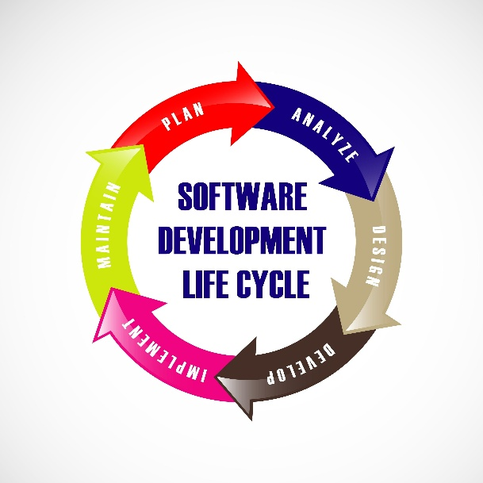

- Defect Reporting Procedure:
- Logging: Any Deviation from expected behaviour/result will be logged as defects.
- Scope: Functional and Usability issues will also be reported.
- Validation: Defect must be retested to verify reproducibility before logging.
- Evidence: Screenshots and reproduction steps will be captured.
- Tracking: Daily status report shared via Excel.

- Entry & Exit Criteria of STLC phase:
STLC Phase | Entry | Exit
Requirement Analysis | Requirements received | Requirements understood and doubts clarified
Test Planning | Testable Requirements available | Test Plan prepared
Test Design | Test Plan approved | Test Scenario and Test Cases prepared
Test Execution | Stable build available | Test execution and defect report ready
Test Closure | All reports prepared | Test Closure Report completed

- Test Completion Criteria
  - All critical defects fixed and verified
  - All test cases executed.
  - All Planned deliverables completed.
  - Performance test (if applicable) meets expected limits.

- Risks and Mitigations
Risks | Mitigation
Non-availability of resources | Plan backup resources
Build URL not working | Work on alternate test activities

- Approvals
Following documents need client’s approval:
- Test Plan
- Test Scenarios
- Test Cases
- Test Reports

- Test Deliverables:
  - Test Cases
  - Test Scenario Document
  - Test Summary Reports
  - Defect Reports

